Jargon Diction

🧪 What is Jargon Diction
# Source: AI Source: Provided by: [Data Path: Persons Table -> ID Column: 1, Name_En Column: Motasem Essam] -> From: [Chatgpt (GPT-4-turbo)] on [7/30/2025]
Jargon diction refers to the use of specialized terminology that is specific to a particular field, profession, or group. These words are often technical and may be difficult for outsiders to understand.

✅ Key Features:
# Source: AI Source: Provided by: [Data Path: Persons Table -> ID Column: 1, Name_En Column: Motasem Essam] -> From: [Chatgpt (GPT-4-turbo)] on [7/30/2025]
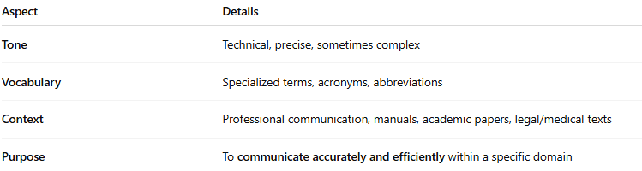
Aspect | Details
Tone | Technical, precise, sometimes complex
Vocabulary | Specialized terms, acronyms, abbreviations
Context | Professional communication, manuals, academic papers, legal/medical texts
Purpose | To communicate accurately and efficiently within a specific domain

🧠 Examples of Jargon by Field:
# Source: AI Source: Provided by: [Data Path: Persons Table -> ID Column: 1, Name_En Column: Motasem Essam] -> From: [Chatgpt (GPT-4-turbo)] on [7/30/2025]
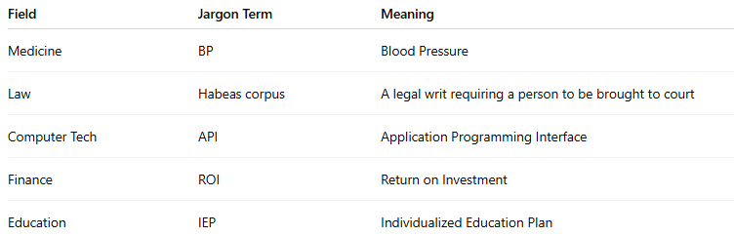
Field | Jargon Term | Meaning
Medicine | BP | Blood Pressure
Law | Habeas corpus | A legal writ requiring a person to be brought to court
Computer Tech | API | Application Programming Interface
Finance | ROI | Return on Investment
Education | IEP | Individualized Education Plan

✍️ Example Sentence Using Jargon Diction:
# Source: AI Source: Provided by: [Data Path: Persons Table -> ID Column: 1, Name_En Column: Motasem Essam] -> From: [Chatgpt (GPT-4-turbo)] on [7/30/2025]
- “The patient presented with elevated BP and signs of tachycardia.”
- “Ensure the software integrates with the existing API framework.”

🆚 Jargon Diction vs Slang Diction:
# Source: AI Source: Provided by: [Data Path: Persons Table -> ID Column: 1, Name_En Column: Motasem Essam] -> From: [Chatgpt (GPT-4-turbo)] on [7/30/2025]
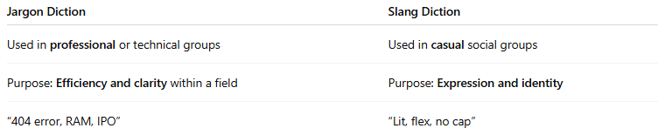
Jargon Diction | Slang Diction
Used in professional or technical groups | Used in casual social groups
Purpose: Efficiency and clarity within a field | Purpose: Expression and identity
“404 error, RAM, IPO” | “Lit, flex, no cap”

⚠️ Important Note:
# Source: AI Source: Provided by: [Data Path: Persons Table -> ID Column: 1, Name_En Column: Motasem Essam] -> From: [Chatgpt (GPT-4-turbo)] on [7/30/2025]
While essential in expert communication, jargon can be confusing or alienating if used with a general audience. Writers often define or avoid jargon when addressing non-specialists.

🧭 Used In:
# Source: AI Source: Provided by: [Data Path: Persons Table -> ID Column: 1, Name_En Column: Motasem Essam] -> From: [Chatgpt (GPT-4-turbo)] on [7/30/2025]
- Professional and academic writing
- Technical documentation
- Workplace communication
- Field-specific training or instruction

